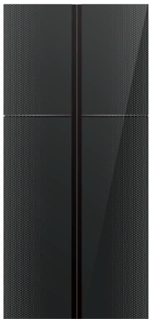

Dawlance Sapphire Inverter Refrigerator
Rs.252,153
Dawlance DFD 900 multi door sapphire inverter refrigerator delivers large family storage, glass door styling, and energy-saving inverter cooling.

Specifications
- Model: DFD 900
- Capacity: 570-600 Litres
- Type: Multi Door Refrigerator
- Compressor: Rotary Inverter

Key Features
- Glass door design
- Multi airflow system
- Automatic defrost
- Quick freeze function

